**6. Sound generated by formula**

**6.1 Aim**

To write a python code that can generate sound of desired frequency of 440 Hz using sine wave mathematical expression

**6.2 Software used**

Anaconda Navigator, Jupyter Notebook

**6.3 Pre-lab**

1. Why the direct sine wave generated samples can’t be played without 16 bit data conversion?
2. Give the calculation for generating the number of samples if we want 10 sec to play audio and the sampling frequency is 5000 samples/sec.

**6.4 Procedure**

1. Open Anaconda Navigator and open jupyterNotebook.
2. Import simple audio and numpy packages.
3. Give the input frequency as 440Hz , sampling frequency as 44100 Hz and seconds as 4 (which counts upto 3only).
4. Create array with seconds*sample_rate steps, ranging between 0 and seconds.
5. Generate a 440 Hz sine wave.
6. Ensure that the highest value is in the 16-bit range.
7. Convert highest value to 16-bit data.
8. Start playback and Wait for playback to finish before exiting.
9. Run the program and get output.

**6.5 Flowchart**

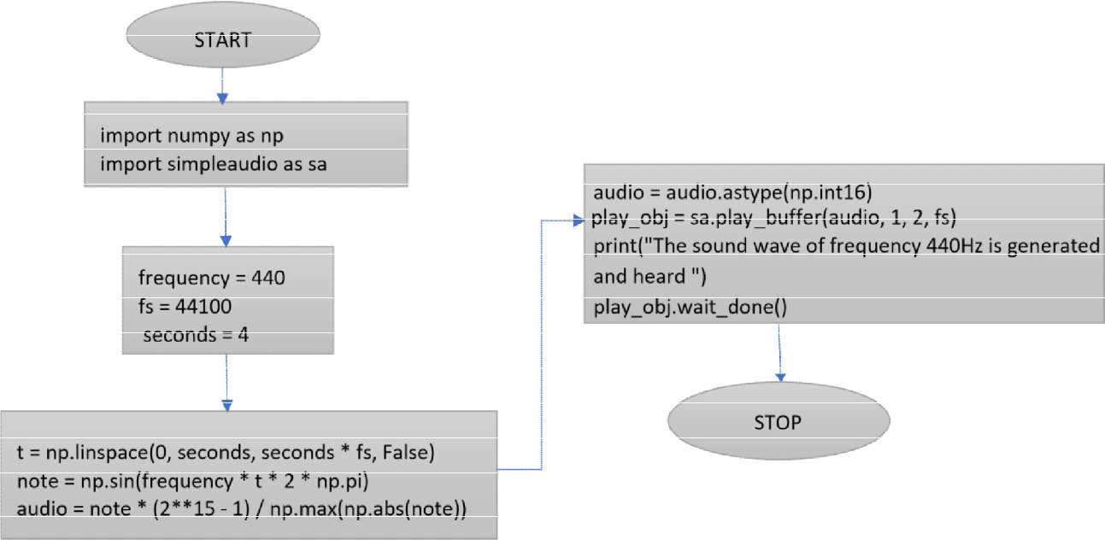

**Input Table**

|  |  |  |  |  |
| --- | --- | --- | --- | --- |
| **Libraries Used** | **Frequency of**  **Sound wave (Hz)** | **Number of Seconds** | **Generation of 440 Hz** | **Playback Formula** |
| Numpy  Simple audio | Frequency = 440 | Fs = 44100 | Note = np.sin(frequency*t*2*  np.pi) | Play.obj = sa.play.buffer(audio,1,2,fs) |

**6.6 Program and Output**

**Code:**

pip install simpleaudio

# RA2011004010051 - Python - Experiment 6

import numpy as np

import simpleaudio as sa

frequency=440

fs=44100

seconds=10

t=np.linspace(0,seconds,seconds*fs,False)

note=np.sin(frequency*t*2*np.pi)

audio=note*(2**15-1)/np.max(np.abs(note))

audio=audio.astype(np.int16)

play_obj=sa.play_buffer(audio,2,2,fs)

print("the sound wave of frequency 440Hz is generated and heard")

play_obj.wait_done()

**Output:**

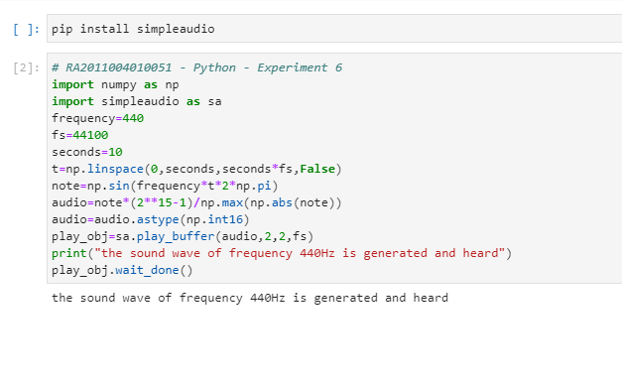

* 1. **Post-lab**

1. Give the command for starting the playback and explain the syntax and usage.

2. Give the mathematics of Piano note frequency generation.

**6.8 Result**

Generation of sound using formula and difference equation is performed, executed properly and it is heard.